NATURAL PRECIOUS METALS cc

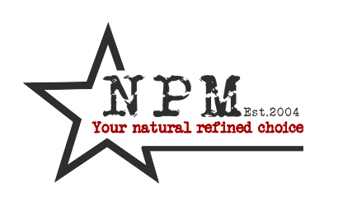

**POLICY: HUMAN RIGHTS**

|  |  |  |  |
| --- | --- | --- | --- |
| VERSION NUMBER | REVIEWERS DATE | NEXT REVIEW | REVISION DETAILS |
| 1 | 22/Oct/2014 | Sept 2015 | Nikki Pavlakis |
|  |  |  |  |
|  |  |  |  |

**PURPOSE**

The purpose of this policy is to ensure that Natural Precious Metals demonstrates its commitment to acceptable human rights standards. Natural Precious Metals is committed to providing a work environment in which every employee is treated fairly, respected, has the opportunity to contribute to business success and also to realise their full potential as individuals.

**SCOPE**

This policy will apply to employees at every level of Natural Precious Metals.

**GENERAL PRINCIPLES**

1. In order to protect the inherent dignity of its employees, Natural Precious Metals subscribes to the following principles:

* Employees have the right to have their dignity respected and protected on Working conditions and practices will not infringe on the dignity of employees
* Physical, sexual, racial, religious, psychological, verbal or any other form of harassment, threat or abuse, whether manifested in behaviour, language or gesture is strongly condemned and will not be tolerated.
* Corporal punishment, mental or physical coercion or verbal abuse will not be tolerated, encouraged or supported Employees have the right of freedom of association as it relates to cultural, religious or linguistic communities of their choice
* Employees have the right to make political choices and to exercise these rights outside of working hours
* Employees and employers will be free to form associations for the protection of their interest and to bargain collectively but will not be compelled to do so
* Every person has a right to equal treatment with respect to employment without discrimination because of race, ancestry, place of origin, ethnic origin, sex, sexual orientation, age, marital status, family status, or disability.
* Staff must respect the dignity and rights of all staff
* Harassment is an improper comment or conduct that a person ought to know would be offensive, embarrassing or hurtful.
* Staff must not behave in a manner that may reasonably be perceived as intimidating or threatening.
* Staff must not influence outcomes with threats or bribes
* Staff must not behave in an abusive way towards other staff and tenants. For Example:
* Initiating or spreading rumours
* Swearing at someone
* Using insulting words or gestures
* Making physical threats
* Assaulting someone physically
* Creating unwanted sexual attention
* Making threatening gestures or remarks

**Enforcement**

* Failure to comply with the principles herein will be a breach of Company Policy and could result in disciplinary action being instituted.

**Violation of the Human Rights Policy**

Reporting Violations of Human Rights:

* It is the responsibility of everyone to ensure that standards of conduct are implemented and maintained, and to seek remedies when standards are violated using established channels.

Consequences:

* Violation may result in either the dismissal of staff. In certain circumstances, violators of the Human Rights Policy may also be violators of legislation which could result in other sanctions as dictated by law.

It is the employee’s responsibility to contact management should he / she have any queries.